Model Global Parliament,
Convened in the Legislative Assembly
in the Parliament of NSW, Sydney, Australia
Friday 18 September 2015
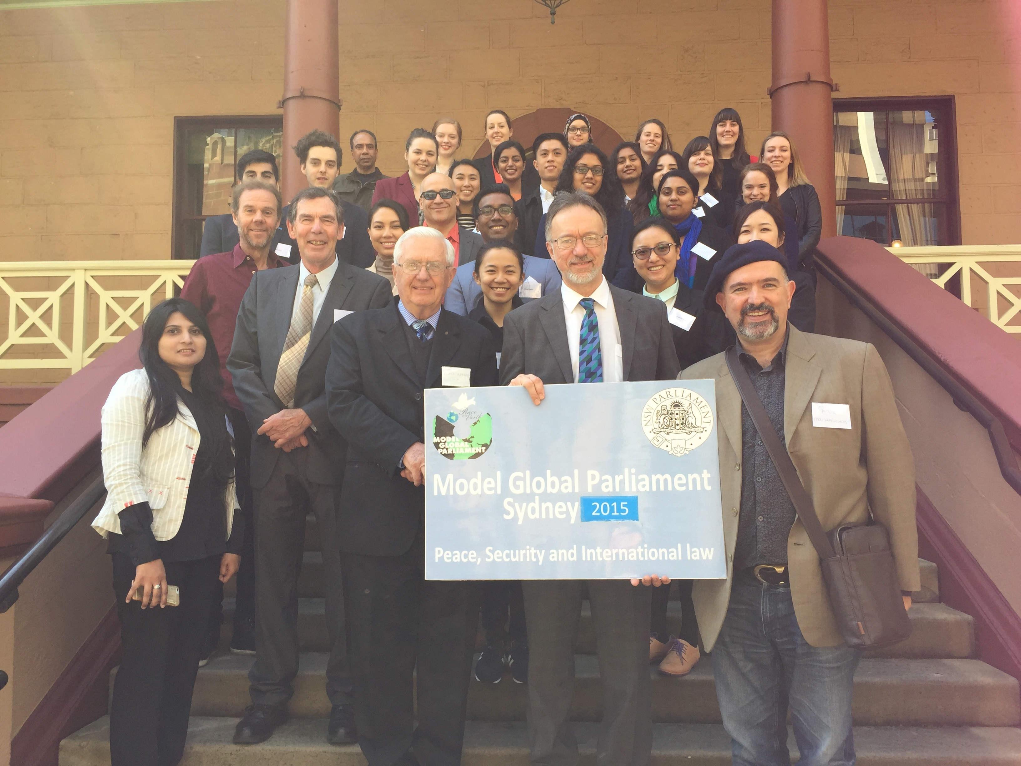

Communiqué
Attendance at our 3rd Model Global Parliament in Sydney was modest, but as always included an extraordinary mix of students and others from many different nationalities, including Syria, Italy, Turkey, Sri Lanka, China/Spain, Ireland, Singapore, New Zealand, Egypt, Hong Kong, Palestine, Australia (!) and Bangladesh! The concept generally seems to appeal more to international students than the locals.
Proceedings began with a welcome to the NSW Parliament building from Mr David Shoebridge, MP, kindly filling in for Mr Jamie Parker, MP for Balmain, who had to pull out at the last minute. David Shoebridge gave us a little bit of history, noting that the NSW Parliament was one of the oldest on earth, dating back to 1824, but did not become fully democratic till 1918, when women were finally entitled to stand for Parliament. So democratic government in New South Wales is only a little over 100 years old. He also noted some of the current challenges to democratic governance and procedures around the world.
Next Daryl Le Cornu, the new President of the World Citizens Association of Australia, gave a short outline of why the WCA supports the idea of a global parliament. He noted that ‘problems without passports’ such as climate change require all of us to work together. He noted the massive achievement embodied in the UN, but the difficult problems in procuring its reform. He finished with a pointer to the Earth Federation of the future, foreshadowed in ‘Star Trek’.
Peter Mousaferiadis, Patron of the MGP program and CEO of Cultural Infusion, addressed the meeting on the theme of Peace, its different meanings and its symbols throughout history, one of which is the wreath. He noted the need to measure peace, as the Global Peace Index is endeavouring to do. He noted that the cost of conflict is estimated to be about 13% of the world’s GDP at present!
A group photo was taken on the steps of Parliament House.
The formal session, the 8th Session of the MGP, opened at 10:35am with a roll call and adoption of the draft agenda.

After the morning tea break at 11:00, a session took place on the theme of climate change, looking forward to the global conference in Paris at the end of the year. A/Prof Chris Hamer, President of Scientists for Global Responsibility, gave a quick rundown of the conventional view of the facts behind climate change, as given by the IPCC. Dr Howard Brady, an Antarctic geologist, gave the sceptical viewpoint, arguing the need not to panic, but to slow down and give time for infant technologies to develop. Debate of the motions put forward to the MGP followed.

The Model Global Parliament concluded with a note of thanks to all. We all stood and together affirmed our commitment to the ideals of world citizenship and a global community in the following words:

”I recognize the humanity I share with all people, and I declare myself to be a citizen of the world.
I will uphold the universal rights of others, regardless of nationality, race, religion, age or gender, and
I will endeavour to work with my fellow citizens to create a better world.”
The following motions were voted upon:
Motion 1: North Asia
Motion Carried
Noting the increasing concerns over global environmental issues,
Calls for the creation of a global umbrella group instead of establishing a new institution, which will act as a research facility, think-tank, and information bank for the wider public. The Global Institute for 'Green' Innovation (GIGI) will have a headquarters in North Asia coordinating regional hubs, and will be internationally renowned as a hotspot for innovative renewable energy technology. The institute will include a significant scientific research division with focus areas being the development of ground-breaking 'green' technologies on an international scale.
Motion 2: International Union for the Conservation of Nature
Motion defeated
Considering that setting of emissions reduction targets is hindered by differing viewpoints over appropriate accountabilities of developing and developed nations.
Proposes that the target agreed-upon in Paris informs resolution of these conflicting views by incorporating objective, crowd-sourced data around human dependence on nature/natural resources and the contribution of nature to people’s livelihoods.
Motion 3: World Parliament of Religions\
Motion carried
Noting that more than eight in ten people worldwide identify with a religious group, religious adherence should be given greater acknowledgement by the United Nations.
Calls upon the United Nations to establish a Council of Religions and also to bring the religious groups into discussion, to give a voice to religious groups, and to ensure their interests are represented in policy.
Motion 4: Latin America
Motion Defeated
Noting the power imbalance in the UN Security Council and the changing dynamics of global power.
Calls on the United Nations General Assembly to vote to amend the Charter to include Brazil as a permanent member of the United Nations Security Council.
Motion 5: Universities
Motion Defeated
Noting that the UNSC is becoming increasingly ineffective in stopping transnational wars as in Iraq, Syria and Yemen,
Calls on the UNSC to disband and to allow the UNGA to make decisions involving global security on an 85% supermajority vote.

Other motions put forward by the Middle East and Global Civil Society Organisations were unfortunately not debated due to shortage of time.

