Model Global Parliament
Convened in the Legislative Assembly
in the Parliament of NSW, Sydney, Australia
Monday 12 September 2016
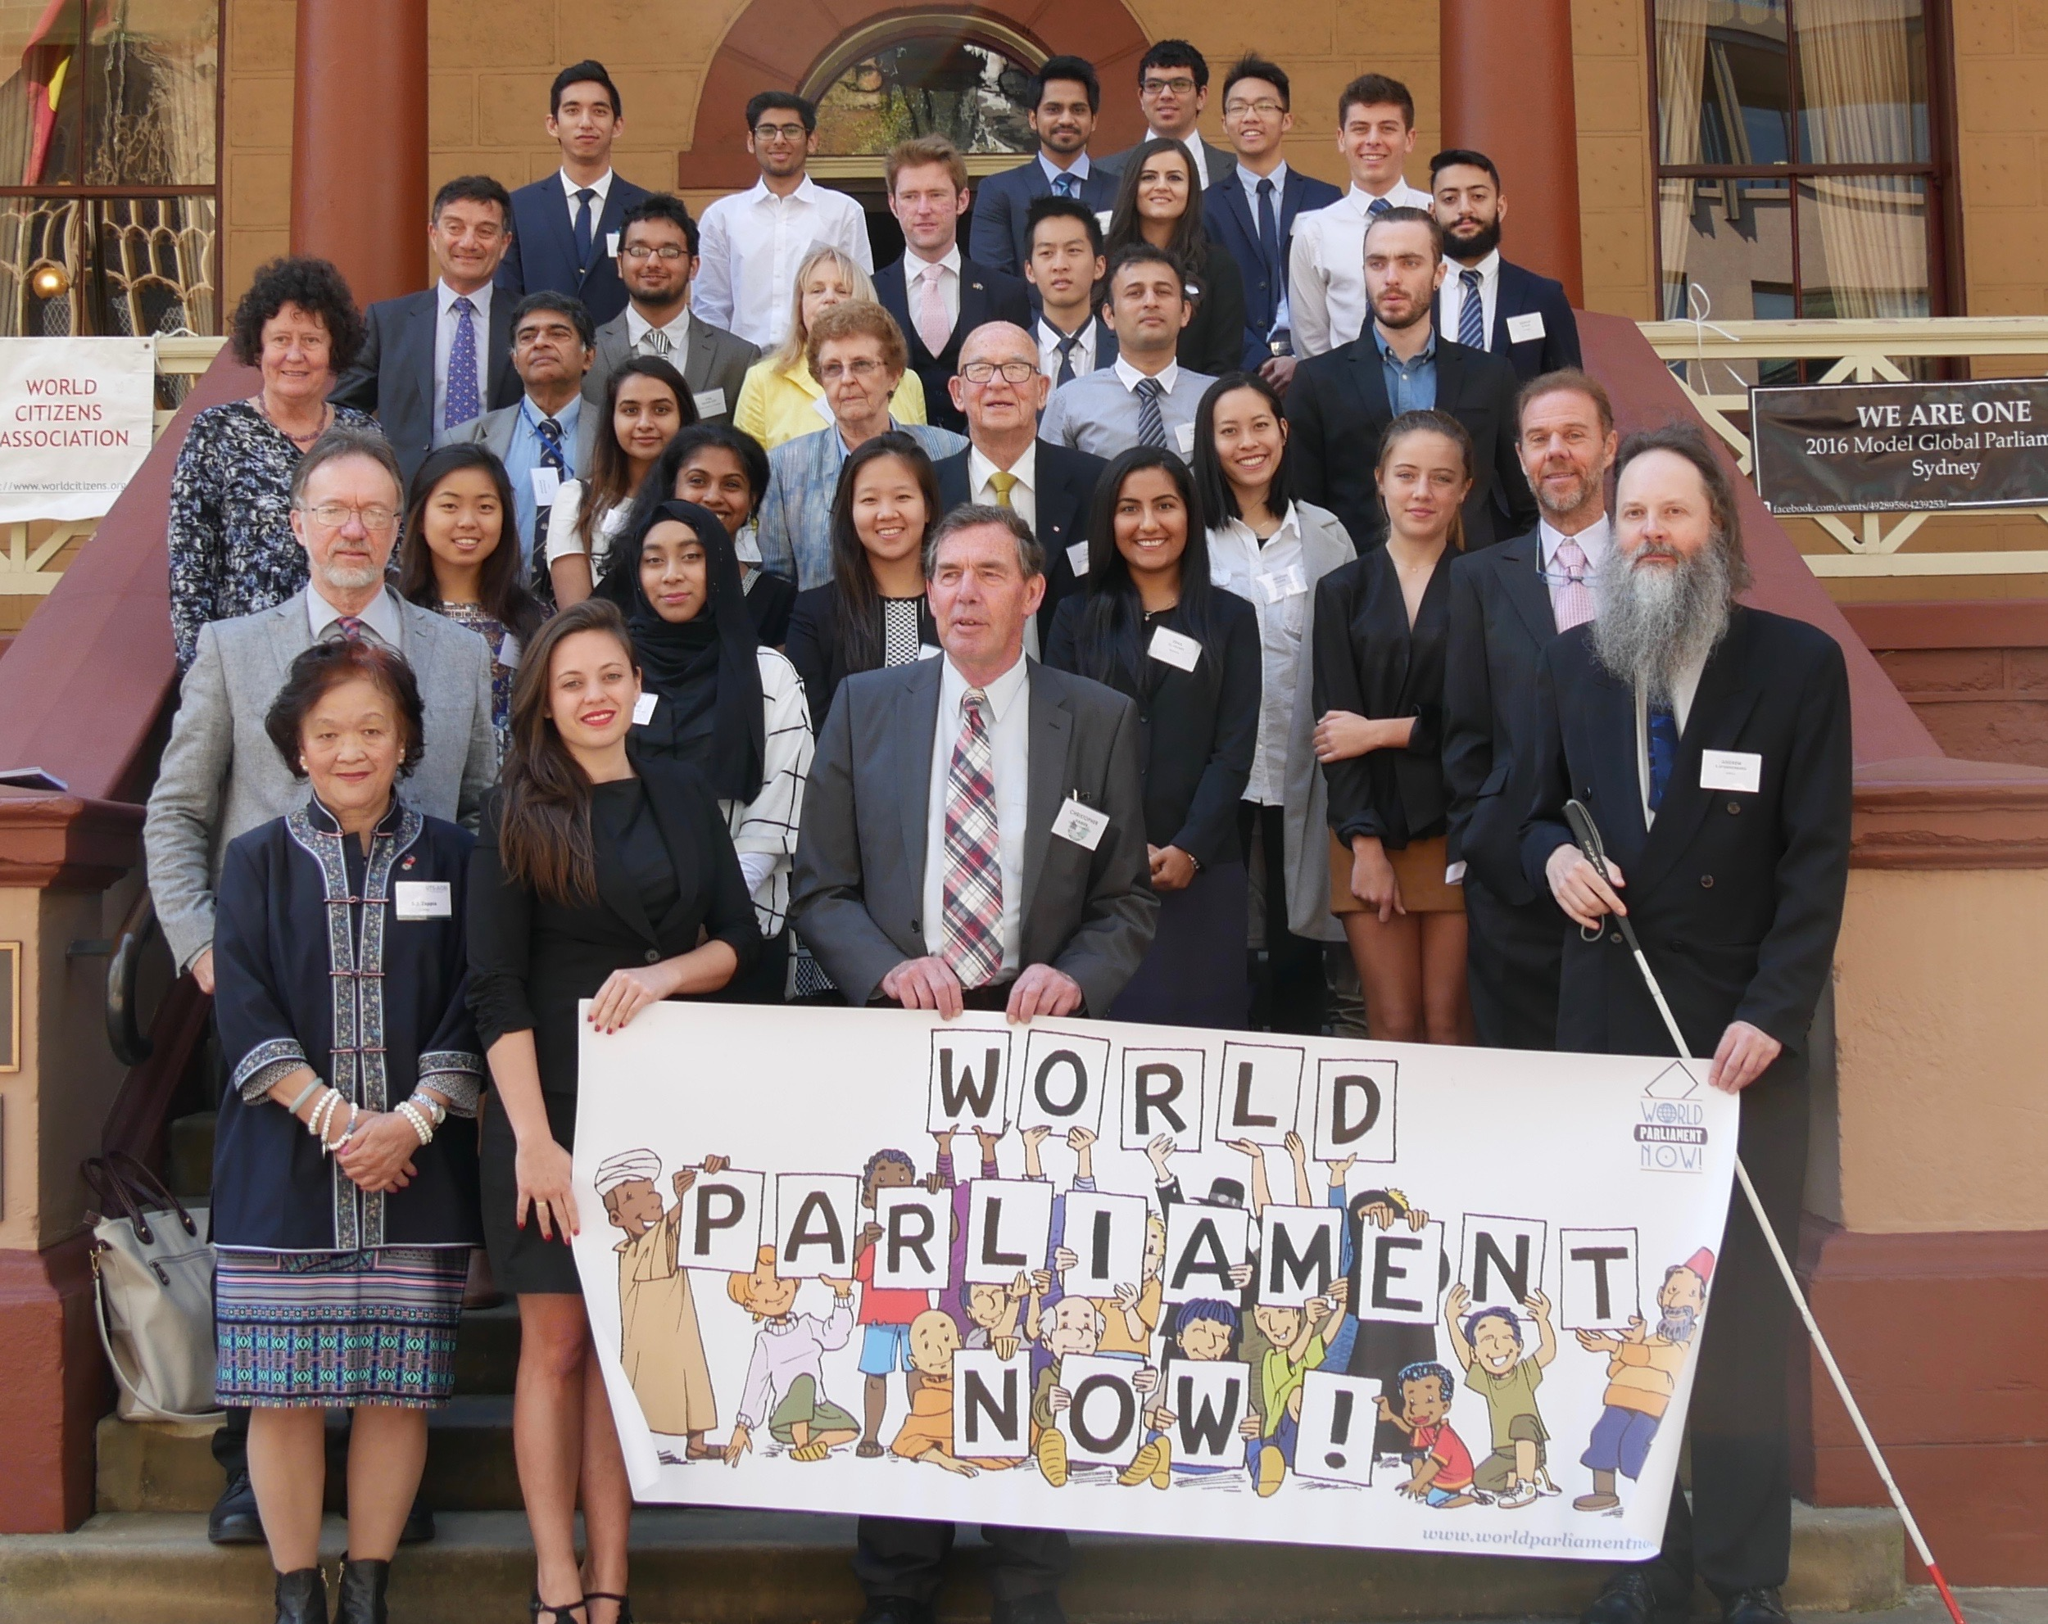
Members of the Model Global Parliament on the steps of Parliament House

The 4th Model Global Parliament in Sydney took place in the plush surroundings of the Legislative Assembly chamber of the New South Wales Parliament. Proceedings began
with a short talk by Daryl Le Cornu, President of the World Citizens Association, who welcomed participants to the Parliament, gave a little background as to why we need a global parliament, and mentioned some current projects such as the Campaign for a United Nations Parliamentary Assembly.

He was followed by Pera Wells, the founder and director of the Model Global Parliament program, who pointed out that people are increasingly identifying themselves as global citizens, recognising that we are living through an unprecedented period of human history. We are living in the so-called Anthropocene Era, where human actions are changing the face of the planet, and we need to regulate properly our effects on the environment. She also told us about the Global Parliament of Mayors, which is taking place virtually as we speak. Unfortunately no Australian mayors were free to attend, as far as we know.

She was followed by Talia Hagerty, a Research Associate at the Institute of Peace, who told the Parliament about the Global Peace Index put out the IEP. This is a remarkable Australian invention due to Steve Killelea, a way of actually measuring the level of peace in various regions of the world, and the various factors that go into that. She summarized recent findings, that despite all appearances, peace has been steadily improving in most countries since 2005, and that democracies and high-income countries consistently have the strongrest levels of peace.
A group photo was taken on the steps of Parliament House.
After the group photo, we had a final short talk from Steven Freeland, Professor of International Law at Western Sydney University, who talked about the need for stronger international law to preserve the environment during war. The International Criminal Court was a great step forward in prosecuting crimes against humanity and genocide during war. Now we need to be able to prosecute crimes against the environment during war, such as a wholesale ‘scorched earth’ catastrophe that took place in Norway during World War II, or the use of weapons of mass destruction that could make large areas of earth uninhabitable for centuries.
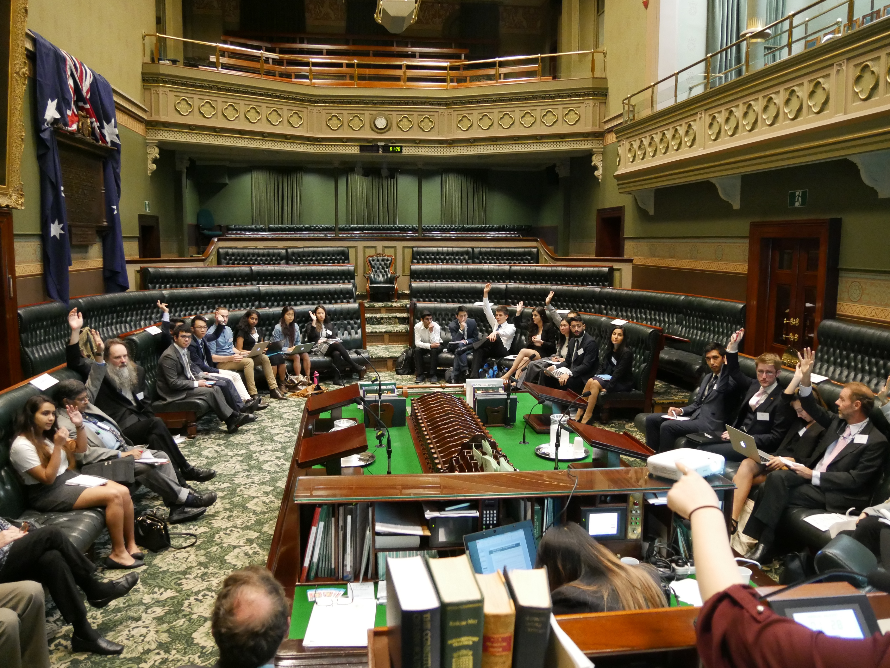
A vote takes place in the Legislative Assembly chamber
After morning tea, the Parliament got down to business, debating the motions before the House. Some vigorous debates took place, and time was insufficient to debate all the motions in full. The rest of the morning session was spent on the topics of human rights, particularly the current refugee crisis, and reform of the UN. The afternoon sessions dealt with the environment, particularly the problem of climate change, and nuclear policy.
The Model Global Parliament concluded with a note of thanks to all. Especial thanks went to the Steering Committee for all their efforts and hard work:
Steering Committee
Karen Wang (Chair)
Kelly Wu
Anup Serkar
Omar Zreika

Finally, we all stood and together affirmed our commitment to the ideals of world citizenship and a global community in the following words:

”I recognize the humanity I share with all people, and I declare myself to be a citizen of the world.
I will uphold the universal rights of others, regardless of nationality, race, religion, age or gender, and
I will endeavour to work with my fellow citizens to create a better world.”
The joint Speaker, Kelly Wu, said that "I believe it has been a fantastic way for people who think of themselves as global citizens to engage each other in debates on issues that matter to them. The student participants, from many countries around the world, enjoyed giving voice to their values while learning how to perform as parliamentarians".

John Hegarty, representing senior citizens, said "This global parliament has been an unique opportunity to sow ideas in an historic place that can have enormous possibilities toward world cooperation, based on democratic global governance and binding international law".

The Model Global Parliament concluded with the decision of participants to support the Fourth Global Week of Action for a World Parliament, 20-30 October 2016.
See http://worldparliamentnow.org

Let the people decide. We need democracy without borders. We need to build global democracy. We need a world parliament!

The following motions were voted upon:
Human Rights and Reform of the UN
Africa – Universal Education
Recognizing the significant role education plays in societal development;
The Model Global Parliament hereby
Calls for the implementation of compulsory education for all individuals worldwide, regardless of age, sex, gender, race or religious beliefs,
Recommends the implementation of a standardized international curriculum focusing on the UN's nine core international human rights treaties, multiculturalism, technological innovations and business development in the early stages of learning.
South America – Human Trafficking

South America – Human T “Human trafficking affects us all, whether we live in countries of origin, transit or destination. Preventing and combining requires a comprehensive international approach. We must act together to stop a crime in our midst that deprives countless victims of their liberty, dignity and human rights.”
Ms.Asha-Rose Migiro, Deputy Secretary-General of the United Nations
The Model Global Parliament
Recognizing the growth of the human trafficking problem in Latin America and the Caribbean, and the need for an urgent solution;
The Model Global Parliament hereby
Expresses its full support to finding a solution to preventing human trafficking.
North Asia – UNSC Reform
The Model Global Parliament,
Expressing concern that the current configuration of the UNSC disproportionately represents the different regions of the world, particularly Asia and Africa,
Recalling the successful expansion of the United Nations Security Council from eleven to fifteen non-permanent member seats in 1965,
Recalling former Secretary-General Kofi Annan’s call for an expansion of the United Nations to a council of 24 nations (21 March, 2005), with specific reference to Plan A,
Recalling support expressed by sitting permanent members of the UNSC for aspiring permanent members, particularly the ‘G4’;
The Model Global Parliament
Expresses full support for the expansion of the United Nations Security Council from five to eleven permanent member seats.
International Security
Europe – Refugee Relocation
The Model Global Parliament
Noting the largest refugee population since World War II,
Noting some countries and regions disproportionate intake and accommodation of aforesaid refugees;
The Model Global Parliament hereby
Proposes a mandatory, fair and equitable allocation and transfer of all current refugees, to countries and areas of the world,
in proportion to their economic and geographic capabilities,
within the next three years,
to abide by the global obligations of the UN Refugee Convention;
Calls upon the global parliament to move to set up an independent commission within 6 months from today, who working closely with the UNHCR, UN Peacekeepers, the UN assembly, business and NGO’s must:
- Determine alternative strategies to achieve the above said “fair and equitable allocation”
- Determine the funding, resources and expected outcomes for the abovementioned strategies.
- Allow a democratic vote at the GP, within 12 months to decide on the optimal win-win strategy from the above choices, to achieve the goals above.
Middle East – Refugee Fund
The Model Global Parliament
Understanding the political situation surrounding refugee movements in the wake of the Iraqi and Syrian Civil Wars,
Recognizing the lack of legal protections surrounding refugees in urban settlements across the Middle East, Africa and South Asia,
Conceding that not enough has been done by many states to protect the rights and freedoms of those fleeing persecution,
Identifying that access to food and water, shelter, education and health care services are often lacking for many refugees in countries of first asylum,
Noting that prolonged displacement under these conditions forces refugees to take drastic and risky journeys in the hope of a more stable and safer life;
The Model Global Parliament hereby
Calls upon all states to contribute to a world refugee fund in order to allow states of first asylum to cope with potentially massive influxes should they meet minimum requirements.
International Seniors Organisation – Displaced Persons
The Model Global Parliament
Recognising threats to international security and human rights caused by massive movement of displaced persons,
Recognising existing procedures are only applicable to small groups of individuals;
The Model Global Parliament hereby
Urges nations to provide extensive resources to plan for sudden massive intakes,
Urge nations to implement small group theory by encouraging and supporting refugees to form self-managed and disciplined small groups committed to integrating into their new home nation.
Environment and Nuclear Issues
Central America & Caribbean/South Asia – Nuclear Sanctions
The Model Global Parliament
Recognising the unpredictable threat nuclear weapons carry to humanity,
Noting Japan’s ongoing recovering from the nuclear bombings in Hiroshima and Nagasaki till this day,
Understanding that humanity and nuclear weapons can not co-exist,
Understanding that peace could only be achieved through the destruction of nuclear weapons;
The Model Global Parliament hereby
Calls for the sanction on nuclear weapons and the production of such,
Aiming to disarm all states of nuclear weapons to the purpose of achieving peace and sustaining humanity.
North Asia – Formation of the International Nuclear Disaster Response Organisation
The Model Global Parliament
Recalling the disaster as Chernobyl Nuclear Power Plant in April 1986 and its enduring impacts on the environment and the lives of its victims,
Recalling the Convention on Assistance in the Case of a Nuclear Accident or Radiological Emergency adopted by the International Atomic Energy Agency (IAEA) following the Chernobyl disaster in 1986,
Acknowledging the ongoing clean-up operation at the Fukushima Daichi nuclear power plant in Tōhoku Prefecture, Japan, and the various domestic complications hindering this process,
Acknowledging the rapid growth rate of the nuclear power industry around the world, with particular note for the interest in nuclear power expressed by many countries with questionable disaster response capacity;
The Model Global Parliament hereby
Expresses support for the establishment of an International Nuclear Disaster Response Unit, either as an independent agency, or as an extension on the IAEA.
North Asia – Addressing North Korea’s Ongoing Nuclear Weapons Development
The Model Global Parliament
Recalling past diplomatic breakthroughs made towards the suspension and dismantlement of North Korea’s nuclear weapons and ballistic missile programs,
Expressing concern that Pyongyang’s nuclear weapons and ballistic missile programs have progressed despite increasingly harsh financial sanctions instated by the United Nations and other sovereign states independently, and continue to threaten international peace and stability,
Acknowledging expressions made by the North Korean government of its desire for the accordance of a formal peace treaty between the combatants of the Korean War and its willingness to forego nuclear weapons if such an agreement is reached;
The Model Global Parliament hereby
Expresses its support for a conditional relaxation of sanctions against the Democratic People’s Republic of Korea, short of complete nuclear disarmament, in the interests of restarting negotiations for the realisation of peace and nuclear disarmament on the Korean Peninsula.
Middle East – Transition to Solar Energy
The Model Global Parliament
Noting the increased awareness of the issue of climate change,
Acknowledging the recent heatwave in the Middle East which broke temperature records in three countries,
Perceives that temperature records have been shattered globally in the last 12 months,
Recognizes the Middle East benefits greatly from continued exploitation of non-renewable energy resources but has great renewable potential;
The Model Global Parliament hereby
Calls upon all states to work together and help fund an orderly transition from oil to solar as the main form of energy exported from the Middle East.
Central America & Caribbean/South Asia – Climate and Environment
The Model Global Parliament
Noting the dangers of anthropogenic climate change, and the need for immediate remedial action from all world powers,
Recognises the immense impact mankind have on the environments,
Acknowledges that environmental concerns such as pollution, global warming and deforestation are the direct results of mankind’s abuse of natural resources and rapid industrialisation;
The Model Global Parliament hereby
Calls for the international community to unite as a whole to combat such environmental concerns through implementing effective long term and short term strategies,
Expresses its full support for a course of remedial action to combat anthropogenic climate change.

