Report on visit of Andreas Bummel, global director of the campaign for a UN Parliamentary Assembly, and Director of the new association Democracy Without Borders.
(The Canberra component of Andreas’ visit was organized due to the amazing and tireless efforts of Pera Wells, for which much thanks!)

Symposium “Towards a more democratic United Nations”, Thursday 5 September 9.30am–1.00pm
Weston Theatre, JG Crawford Building, ANU
A Symposium sponsored by
World Citizens Association of Australia,
Campaign for a United Nations Parliamentary Assembly
Crawford School of Public Policy, ANU
Institute for Global Peace and Sustainable Governance

Chairs: Pera Wells, Former Secretary-General of the World Federation of United Nations Associations, and Lindy Joubert, Senior Lecturer in Architecture, and founding Director of the inaugural UNESCO Observatory at The University of Melbourne

Speakers:

Andreas Bummel, Global coordinator of the international Campaign for a United Nations
Parliamentary Assembly, and Executive Director of Democracy Without Borders
“Towards a World Parliament: A United Nations Parliamentary Assembly”

Andreas told us about his very impressive campaign for a United Nations Parliamentary Assembly. He began by highlighting the misrepresentative nature of the present UN, where in theory a 2/3 majority of the General Assembly could be assembled by the world’s smallest states making up just 8.4% of the world’s population (which means the great powers will never allow the Assembly to have real power itself). He then talked about how our present system is made up of an assembly of sovereign states, whereas we would like to see a system of global democracy based on the individual citizen, and ‘one man, one vote’: a world parliament.
He then gave us a brief outline of his scheme for a UNPA, as the first step towards an eventual world parliament. It could be set up as a subsidiary body of the General Assembly by a vote of the Assembly itself, without requiring any change in the UN Charter. It would initially be made of MPs elected in their home parliaments, and nominated or selected to take part in the UNPA. It would also initially have a largely advisory role, but hopefully also an oversight role, to the General Assembly. The idea is that it could evolve over time into a genuine world parliament, following the example set by the European parliament.

Ramesh Thakur, Former Assistant Secretary-General of the United Nations.
“Minding the Gaps: The Global Governance of Nuclear Arms Control”

Ramesh talked about five ‘gaps’ in global governance, giving rise to a crisis in the world order, carrying a risk of catastrophic collapse. He referred particularly to the two major problems of climate change and nuclear weapons. The gaps he enumerated as:
- Knowledge: What are the facts, and how should they be explained?
- Normative: the nuclear-armed states plus their allies, including Australia, start from where we are today and therefore forever postpone the disarmament destination as beyond reach. He did note, however, the nuclear ban treaty as a hopeful sign. It is the first humanitarian treaty adopted by the ‘periphery’ to control the behaviour of the ‘core’, and the first example of the UNGA defying the UNSC on security policy
- Policy: he referred to Article VI of the NPT: ‘Each of the Parties to the Treaty undertakes to pursue negotiations in good faith on effective measures relating to cessation of the nuclear arms race at an early date and to nuclear disarmament’. Yet the nuclear powers continue to ignore this undertaking.
- Institutional: he referred to deficits in the NPT, and the lack of any enforcement mechanisms;
- Compliance: e.g. the US exit from the Joint agreement with Iran. We must either reform the Security Council, or build a new body that is fit for purpose.
He then asked the question: can a world parliament help? There are still many questions of design, implementation and politics to be sorted out. He criticised current proposals as too Eurocentric

Chris Hamer, Founder of the World Citizens Association of Australia
“A World Security Community of democratic nations”

Chris first tried to put the UNPA campaign in the context of the broader world federalist movement. They have been trying for 70 years to reform the UN to become a world parliament, but have always been stymied by the rigid UN Charter. In recent years they have lowered their sights, and concentrated on objectives that can be achieved without requiring a change in the Charter, such as the Campaign for the International Criminal Court, or the doctrine of Responsibility to Protect.
He noted four possible paths to a world parliament, and observed that we should support all of them where we can, since nobody can predict where the breakthrough will occur. The UNPA campaign is the most achievable initiative on the table at present, and the most likely to succeed. As a first step along the “Reform the UN” path – hence our current support of his visit.
He finally spent some time discussing an alternative route, the “Uniting the Democracies” path, which in his opinion is the most likely route of all, namely our new initiative for a World Security Community of democratic nations. It has no Charter in the way, and could progress and expand Treaty by Treaty in the same way that the European Union was formed.

Richard Ponzio, Director of the Just Security 2020 Program at the Stimson Institute
“The UN2020 program” (Video conference)

Richard is closely involved with the transnational UN2020 program and the Together First initiative, aiming to get UN reform on the table for international discussion next year, which marks the 75th anniversary of the founding of the UN. He showed the General Assembly Resolution for UN75 A/RES/73/299, 14 June, 2019:
- The theme, “The future we want, the United Nations we need: reaffirming our collective commitment to multilateralism.”
- UN@75 – The UN Secretariat’s ambitious plan for “global dialogues” on “The future we want, the United Nations we need.”
He then talked about Civil Society’s essential role in advocacy related to the UN2020 Summit’s political declaration , and called for dialogues (local, national, regional, global) on the UN we need, leading to a May 2020 Civil Society Forum. He discussed 5 major recommendations
- A UN Parliamentary Network (under Charter Article 22)
- A UN Global Partnership that engages civil society organizations and the business community
- An empowered UN Peacebuilding Council (in place of the UN Trusteeship Council with a special focus on Prevention)
- Revamping UN-G20 relations through a new “G20 +”
- Expansion of the Security Council (short and medium-term proposals)

He advertised a Global Policy Dialogue on Global Security, Justice, and Economic Institutions, 4-5 June, 2019, Washington, D.C. This all gave us a perspective on the international efforts to produce a new impetus for UN reform next year.

Bob Brown, Former parliamentary leader of the Australian Greens Party
“Australia’s role in creating a World Parliament”

Bob Brown gave a forceful and impassioned speech on the reasons we need a world parliament. As a leading environmentalist, he concentrated largely on the current problem of climate change. He pointed out that global carbon emissions are still rising, not falling, and at the current rate we are due for a global temperature rise of 3 degrees by the end of the century, and more beyond. He quoted the latest IPCC Report, that a temperature rise of 6 degrees would mean the extinction of all life on earth! If true, this really highlights the urgency of the problem. It is obvious that global problems need global solutions, and to deal with climate change, as well as other problems, we urgently need a world parliament. The slogan should be ‘One person, one vote, one value, one planet’! He concluded with the suggestion the world parliament could be located right here in Australia – why not? The old Exhibition Buildings in Melbourne could provide a suitable location!
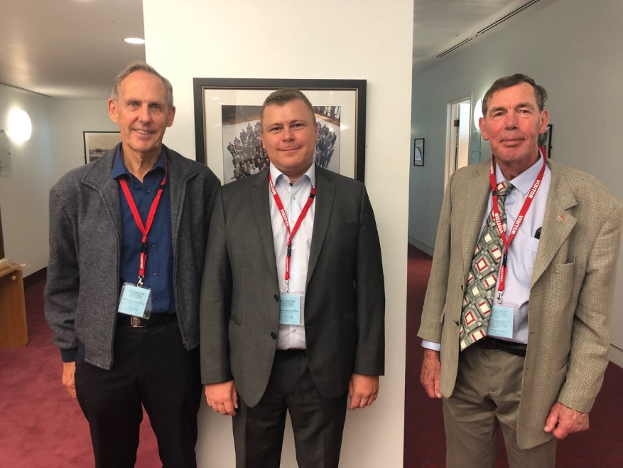
Bob Brown, Andreas Bummel and Chris Hamer at Parliament House.
(Photo courtesy of Roger Hausmann)

Meeting with Justin Lee, First Assistant Secretary, Multilateral Policy Division, and Amy
Prosser at DFAT offices, London Circuit, Friday 6th September 2019.

We (Andreas Bummel, Pera Wells, and Chris Hamer) had a productive meeting with Justin Lee and Amy Prosser from DFAT. We look forward to some ongoing dialogue with DFAT on these issues.

Seminar at Sydney University, 1 pm, Monday September 9th “Strengthening Democratic Global Governance: Towards a World Parliament”

On this occasion Andreas spoke at greater length. He briefly traced the stages of socio-political integration throughout history, starting from the tribe, until now we are in the middle of a global state-formation process. He noted the fundamental problem of state sovereignty, forming a brake on the process, and the current crisis of democracy. He highlighted the need for binding international law, enacted by democratic processes, and then advocated a UN parliamentary Assembly as a first step along the road to a world parliament. Surveys consistently show large majorities of people in favour of a UN Parliament with elected representatives (except in Russia!).
A lengthy discussion followed. Many thanks to Wendy Lambourne for arranging this event.
Roundtable discussion and lunch at the Union Club in Sydney, midday Tuesday September 10th
This event was arranged by Zeny Edwards, with the aim of discussing ways in which we in Australia might be able to support the UNPA Campaign. We will follow up on these ideas as resources permit!
Chris Hamer
18/9/2019

