Model Global Parliament at Parliament House, Melbourne

The Second Model Global Parliament (MGP) was convened in the Legislative Assembly chamber of the Victorian Parliament on Saturday 25 May 2013. One hundred students from 30 different countries and 8 universities in Australia took part.

The event was directed by Pera Wells and a Steering Committee of students from Monash University, including Gaby Macfarlane-Smith, Addie Erwin, Robert Lanyasunya and Paul Neeraj. It was a great occasion, and the students found it a very exciting and educational experience.

A communiqué from the Melbourne event follows

Communiqué

The Second Model Global Parliament (MGP) was convened in the Legislative Assembly chamber of the Victorian Parliament on Saturday 25 May 2013. One hundred students from 30 different countries and 8 universities in Australia engaged in debate with each other about global problems that require global solutions.

At the opening session key note speeches were given by Dr Alice de Jonge,
Prof Chris Hamer, Prof Paul James, Prof Charles Sampford and Ms Pera Wells.

The Hon Bob Brown sent this message:

"Drawing on the best of our character, Earth's community of people is on the threshold of a brilliant new career in togetherness. But we, all together, have to open the door to that future using the powerful key of global democracy. One person, one vote, one value, one planet."

A message was read out from Benjamin Barber, Founding Director of the
Global Interdependence Movement in New York:

"In an interdependent world the only effective citizens are interdependent citizens. You are already there. Thank you all for what you are doing, and what you will do in the weeks and months ahead. "

In the MGP, the students represented regions around the world as well as
non-state global networks. They presented and debated motions under agenda items relating to peace and disarmament, global economic interdependence, global communications, human rights, the globalization of energy and creative arts. Motions were debated on various matters. Quite a few of the motions were not adopted, for various reasons.

The MGP decided:
to set up a subcommittee on the Global Peace Index to take into account different cultural and political emphases about peace and questions of economic and other forms of violence

to establish a Global Indigenous Advisory Council

to call for the expansion of the mandate of the Global Partnership
for Effective Development as established at Busan into an intergovernmental and inter-organizational co-ordinating body for international and aid dispersal

to call upon the international community to take proactive measures to improve labour conditions in sweatshop industries of the global apparel industry and develop robust institutions and policies to monitor and safeguard labour safety standards to avert accidents

· to recognize the importance of languages as representations of the
World’s diverse cultures, and proposed to establish a Global Society of Languages.

In a concluding Feedback session, it was widely agreed that the session had
been very valuable for all participants. It was recommended that another
session be convened.
It was suggested that future sessions would benefit by having the preparatory session at least two weeks in advance so that the groups could
submit motions in advance, indicating their priorities, and to facilitate
ways of working together to coordinate their ideas

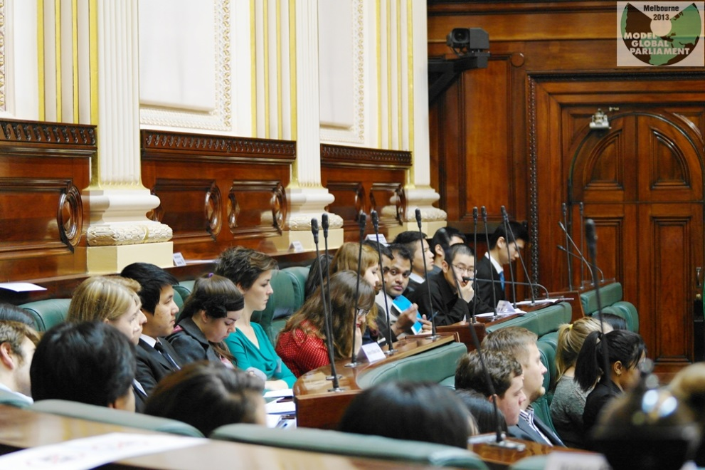
Members of the Model Global Parliament in the Legislative Assembly chamber, Parliament House, Melbourne
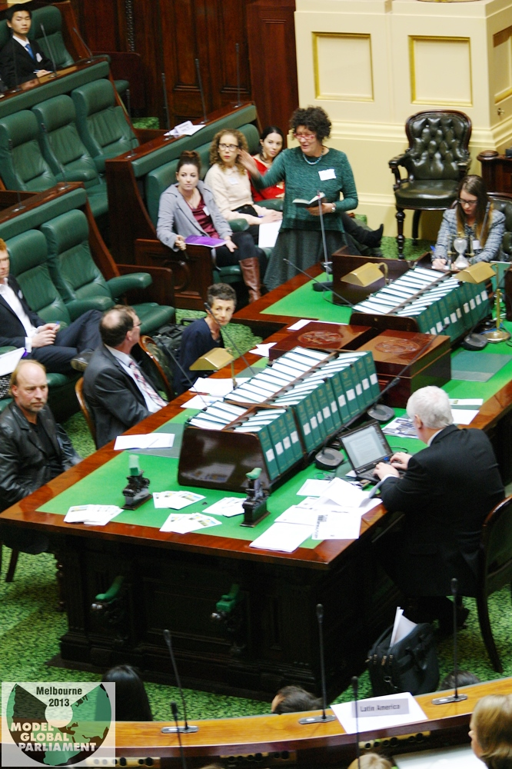
Pera Wells makes a point at the podium

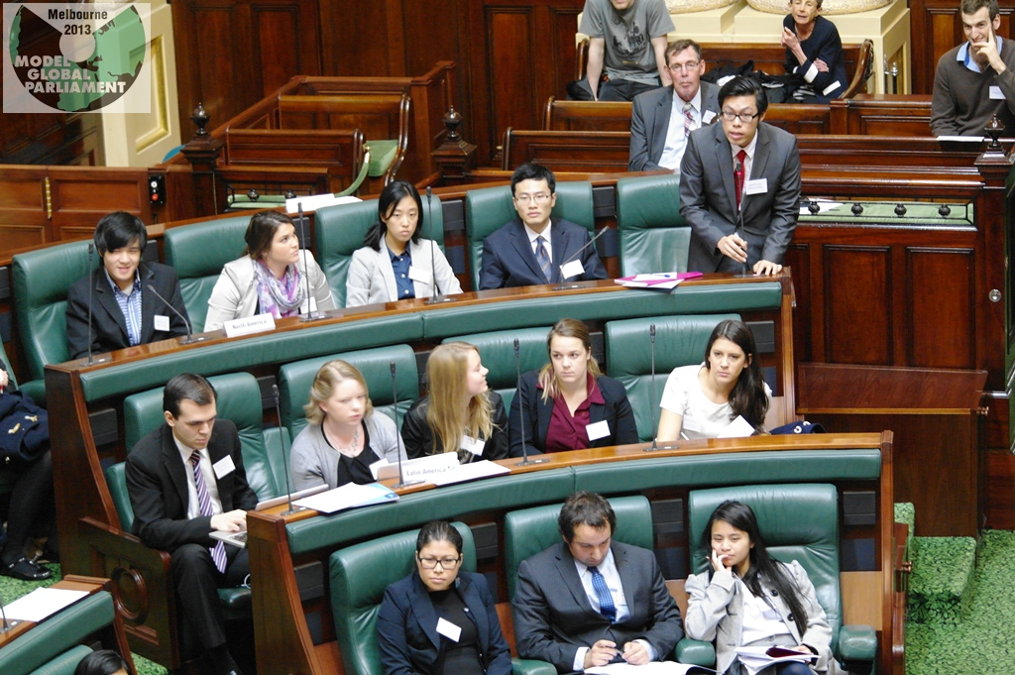
A speaker holds forth in the chamber

